**Relax Project Report**

After cleaning up the dataset and finishing necessary feature engineering, I used SK-learn random forest model to train and predict the data. The accuracy score for this model is 0.932 with optimal parameter that number of trees equals to 3 (as below).

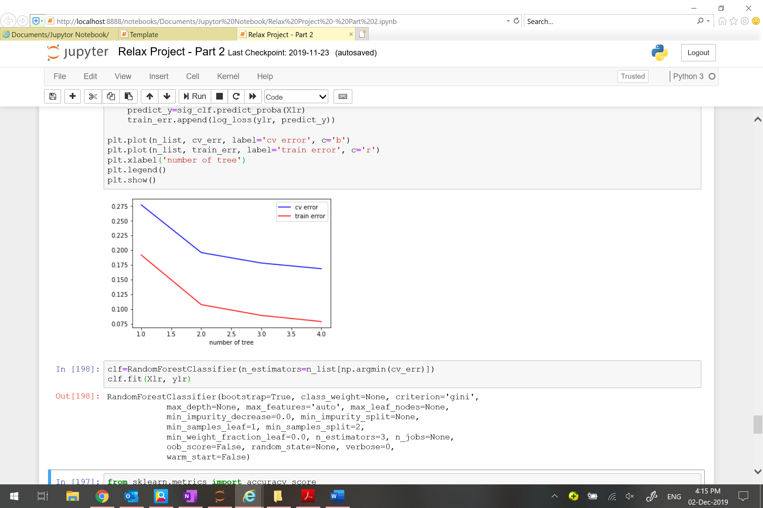

Extracting from the result of random forest model, below table illustrates the importance of features. As we can see, the most important feature to predict whether a user would be adopted or not in the next few months is the last time when he/she used the service. In other words, if a user uses the service more recently, it is more likely that he/she will be adopted in the next couple months.

